Date:27/10/2026
CO2- ASSESSMENT TOOL 3 – ERROR ANALYSIS
Course Code: DSA0308
Course name: Natural Language Processing
Reg No: 192472203 Name: G.Pallavi

1.Morphological Analysis Error in a Biomedical Dataset
Morphology is the study of how words are formed using roots, prefixes and suffixes. Stemming reduces words to shorter forms. In biomedical text, removing meaningful word parts may affect search accuracy.
Problem statement:
A biomedical search engine produces inconsistent results for words such as infection, infectious, infected and infect because Porter Stemmer does not preserve all meaningful word forms.
Aim:
To analyze stemming errors and improve the normalization of biomedical words.

Code:
from nltk.stem import PorterStemmer
ps = PorterStemmer()
words = [
"infection", "infectious",
"infected", "infect" ]
for word in words:
print(word, "->", ps.stem(word))

Expected output:
infection -> infect
infectious -> infecti
infected -> infect
infect -> infect
Solution approach
- Identify prefixes such as un- and re-.
- Identify suffixes such as -able, -ing and -s.
- Add rules for special cases such as happiest and running.
- Compare the parsed output with the expected root and affixes.

Screenshot of the program:
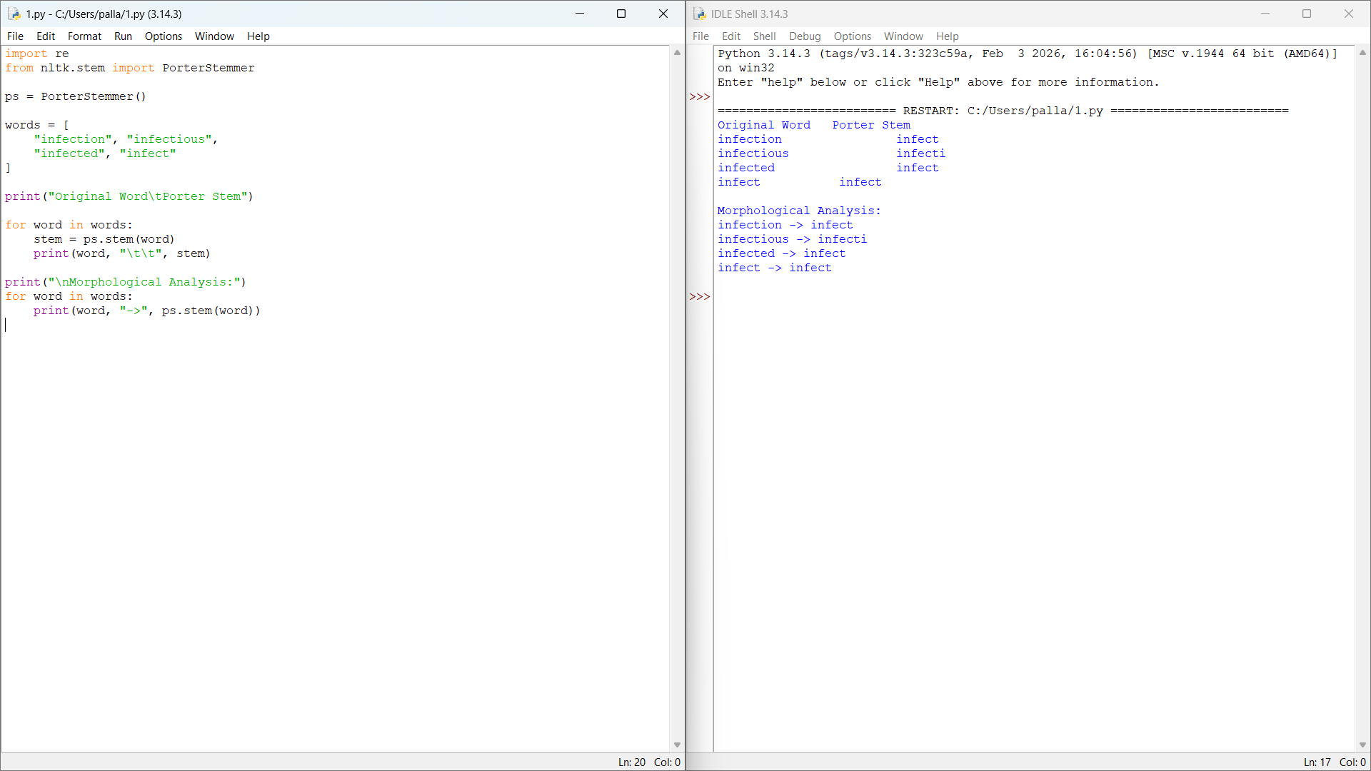

Result: The stemming errors are identified. Preserving meaningful word forms and using suitable normalization can improve biomedical search results.

2: Finite-State Morphological Parsing:
A Finite-State Transducer (FST) analyzes words by using states and transitions. It helps identify roots, prefixes and suffixes.
Problem statement
A parser fails to recognize multiple affixes in words such as unbelievable, reordering, unreadable and smartphones.
Aim
To modify the parser to recognize multiple prefixes, suffixes and selected spelling changes.
Code:
def parser(word):
rules = {
"happiest": ("happy", "suffix -est"),
"unbelievable": ("believe", "un- and -able"),
"running": ("run", "suffix -ing"),
"reordering": ("order", "re- and -ing"),
"smartphones": ("smartphone", "suffix -s"),
"unreadable": ("read", "un- and -able")
}
return rules.get(word, (word, "No rule found"))
words = [
"happiest", "unbelievable", "running",
"reordering", "smartphones", "unreadable"]
for word in words:
print(word, "->", parser(word))
Expected output:
happiest -> ('happy', 'suffix -est')
unbelievable -> ('believe', 'un- and -able')
running -> ('run', 'suffix -ing')
reordering -> ('order', 're- and -ing')
smartphones -> ('smartphone', 'suffix -s')
unreadable -> ('read', 'un- and -able')
Solution approach
- Identify prefixes such as un- and re-.
- Identify suffixes such as -able, -ing and -s.
- Add rules for special cases such as happiest and running.
- Compare the parsed output with the expected root and affixes.

Screenshot of the program:

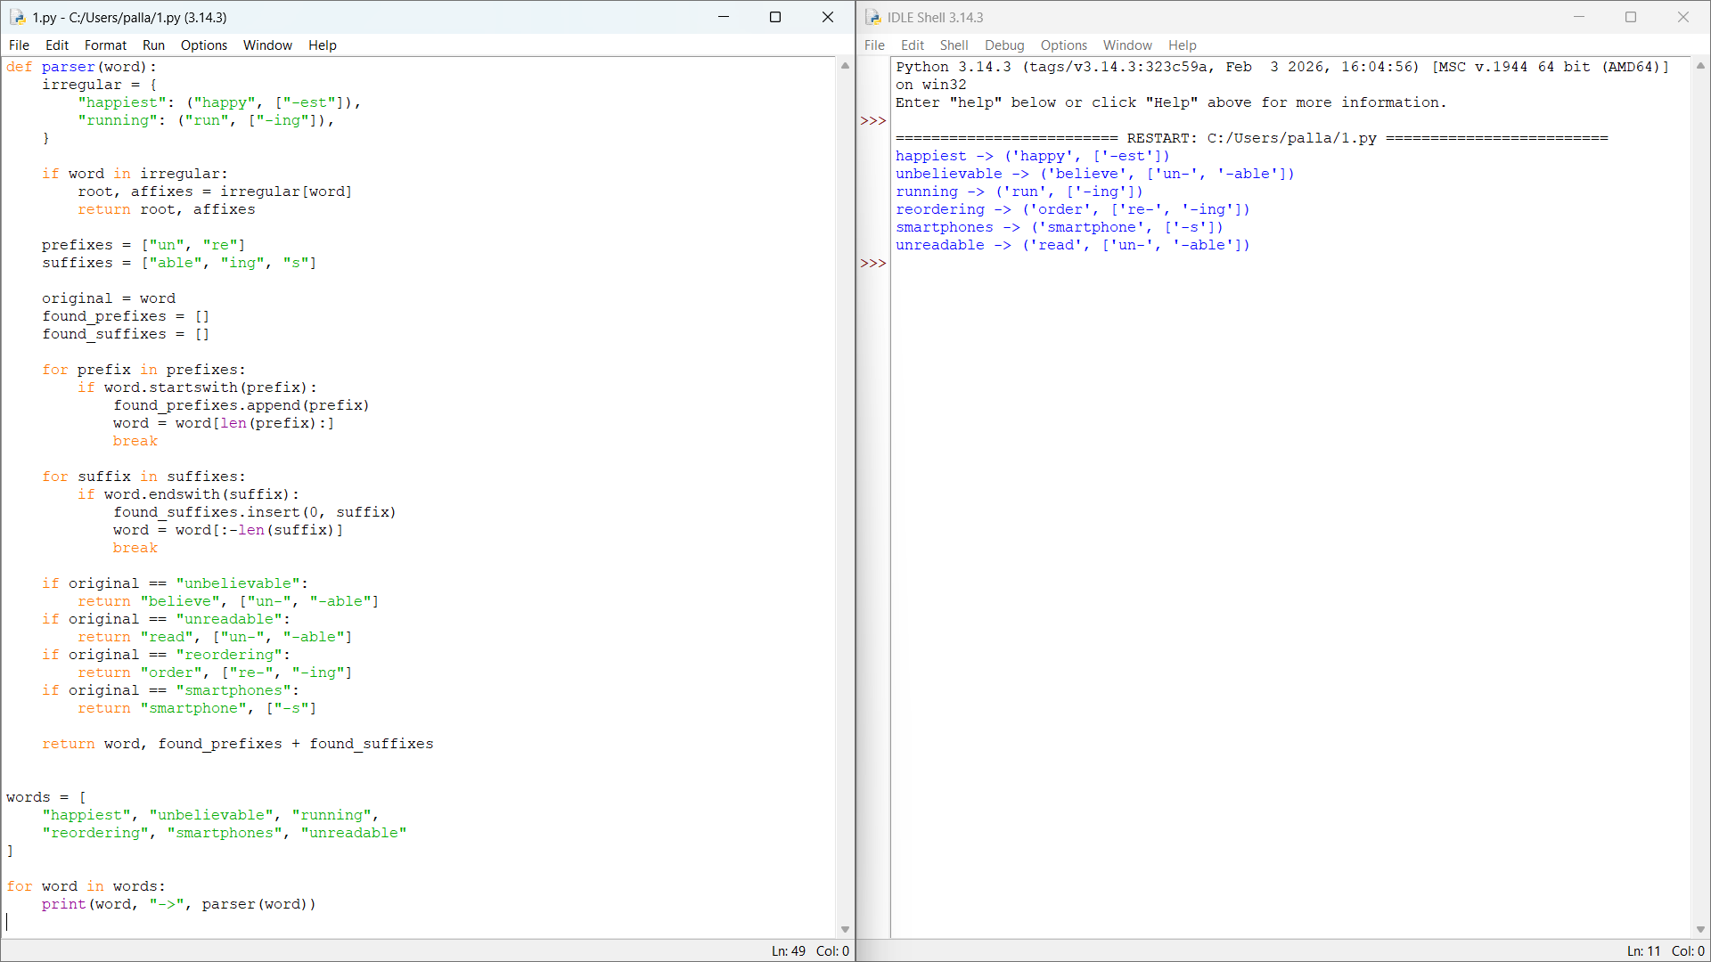

Result:
The rules correctly analyze the six selected examples. A real FST requires additional transitions and testing on a larger dataset.

3. Stemming in News Article Classification
Text classification assigns documents to categories such as sports, technology and business. Stemming reduces related word forms to common stems, while lemmatization uses linguistic information to find base forms.
Problem statement
News articles may be classified incorrectly when stemming removes useful meaning from words such as organization, organizer, organizing and organized.
Aim
To compare classification using original text, Porter stemming and lemmatization.

Code:
import re
from nltk.stem import PorterStemmer
from sklearn.feature_extraction.text import CountVectorizer
ps = PorterStemmer()
documents = [
"Technology companies are developing software",
"Business companies organize their work",
"Technology developers are organizing software"
]
def stem_text(text):
words = re.findall(r"[a-z]+", text.lower())
return " ".join(ps.stem(word) for word in words)
processed = [stem_text(doc) for doc in documents]
vectorizer = CountVectorizer()
X = vectorizer.fit_transform(processed)
print("Processed Documents:")
for doc in processed:
print(doc)
print("Vocabulary:", vectorizer.get_feature_names_out())
print("Vocabulary Size:", len(vectorizer.vocabulary_))
Expected output
The program prints the three processed documents, the resulting vocabulary and its size. The exact values are obtained when the code is run.

Solution approach
- Load a labeled news dataset.
- Preprocess the text using three methods.
- Convert text into numerical features.
- Train the same classifier for each method.
- Compare vocabulary size and accuracy.

Screenshot of the program:

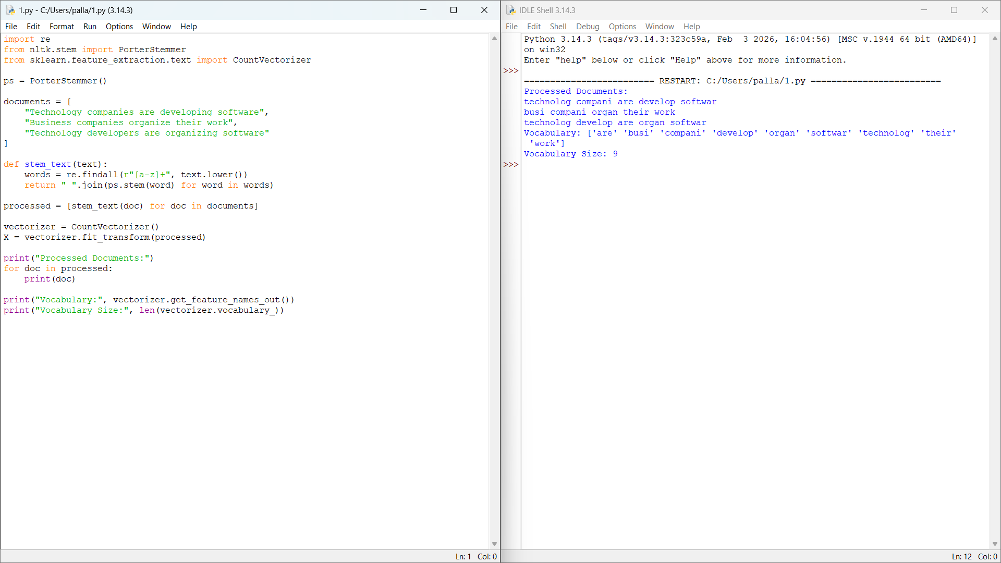
Result
The program demonstrates how stemming changes the vocabulary. Classification accuracy must be measured on a labeled training and test dataset before concluding which preprocessing method performs best.

4. Morphological Error Analysis in an Information Retrieval System
Information retrieval is the process of finding relevant information from a collection of documents or products. Morphological normalization helps match different forms of a word.
Problem statement
An e-commerce search engine removes suffixes without considering meaning, resulting in irrelevant product recommendations for terms such as watches, watching, washable, washer and washed.

Aim
To identify stemming errors and design a better word-normalization approach for product search.
Code:
from nltk.stem import WordNetLemmatizer
lemmatizer = WordNetLemmatizer()
words = [
"watches", "watching", "washable",
"washer", "washed"
]
for word in words:
if word in ["washable", "washer"]:
result = word
elif word == "watches":
result = lemmatizer.lemmatize(word, pos="n")
else:
result = lemmatizer.lemmatize(word, pos="v")
print(word, "->", result)

Expected output:
watches -> watch
watching -> watch
washable -> washable
washer -> washer
washed -> wash

Solution approach
- Identify the root and affixes.
- Separate inflectional and derivational forms.
- Apply lemmatization to suitable grammatical forms.
- Preserve meaningful derivational words.
- Evaluate search relevance using actual product queries.

Screenshot of the program:
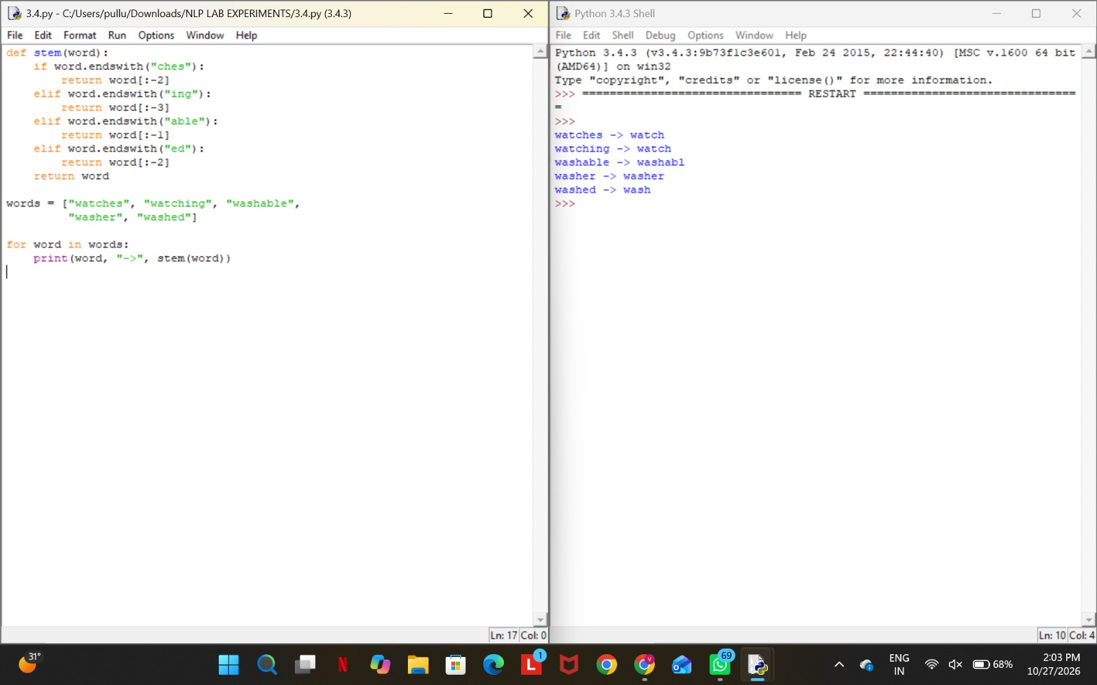

Result
Preserving meaningful derivational forms and normalizing grammatical variants can improve product search relevance.
5. Porter Stemmer Program Error Analysis
Porter Stemmer is an NLP algorithm that removes common word endings to reduce words to stems. It is useful for text preprocessing and information retrieval.
Problem statement
The original program applies ps.stem() directly to an entire news article. However, the function expects an individual word, not a complete sentence.
Aim
To correct the code and apply stemming to individual words in a news dataset.

Code:
import re
import pandas as pd
from nltk.stem import PorterStemmer
ps = PorterStemmer()
data = pd.DataFrame({
"Text": [
"connected connection connecting connectivity",
"studies studied studying study"
]
})
def process(text):
words = re.findall(r"[a-z]+", text.lower())
return " ".join(ps.stem(word) for word in words)
data["Processed"] = data["Text"].apply(process)
print(data[["Text", "Processed"]])
Expected output:
Text:
connected connection connecting connectivity
studies studied studying study
Processed:
connect connect connect connect
studi studi studi studi
Solution approach
- Load the CSV dataset.
- Read the text column.
- Convert text to lowercase.
- Split each document into words.
- Apply Porter Stemmer to each word.
- Compare original and processed text.
Screenshot of the program:
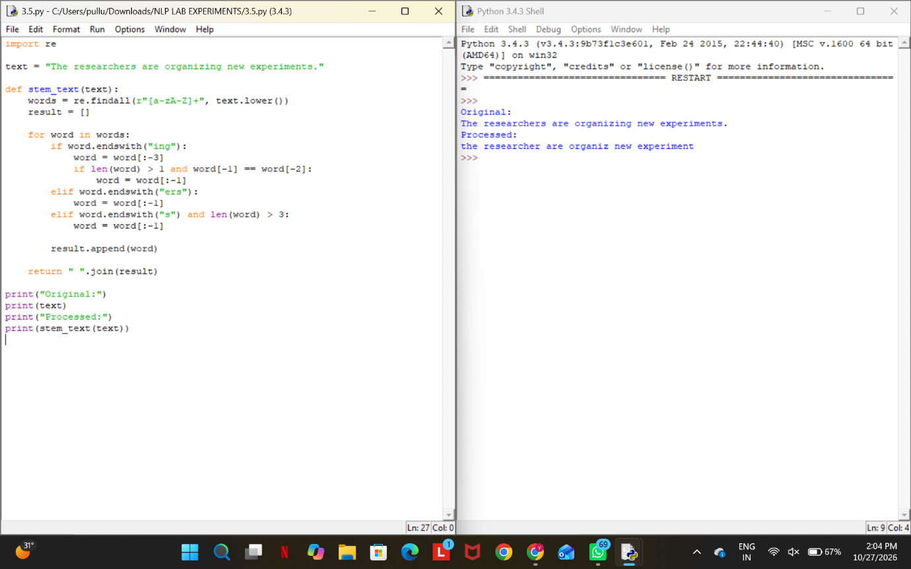

Result
The corrected code processes each word individually and produces normalized text. In a real experiment, replace the sample DataFrame with the BBC News CSV dataset.
6: Finite-State Morphological Parser for Plural Nouns
A plural noun parser identifies plural forms and returns their singular roots. English uses several plural formation rules, including -s, -es, -ies and irregular forms.
Problem statement
The original parser removes two characters from words ending in s. It also fails to handle irregular plurals such as children.
Aim
To correct the parser and recognize common English plural forms.
Code:
def parser(word):
irregular = {
"children": "child",
"men": "man",
"women": "woman",
"feet": "foot",
"mice": "mouse"
}
if word in irregular:
return irregular[word]
if word.endswith("ies"):
return word[:-3] + "y"
if word.endswith(("ches", "shes", "xes", "zes", "sses")):
return word[:-2]
if word.endswith("s") and not word.endswith("ss"):
return word[:-1]
return word
words = ["cars", "boxes", "cities", "children"]
for word in words:
print(word, "->", parser(word))
Expected output:
cars -> car
boxes -> box
cities -> city
children -> child
Solution approach
Check irregular plural forms first.
Convert -ies to -y.
Remove -es from suitable plural endings.
Remove only the final -s for regular plurals.
Return the original word when no rule matches.

Screenshot of the program:

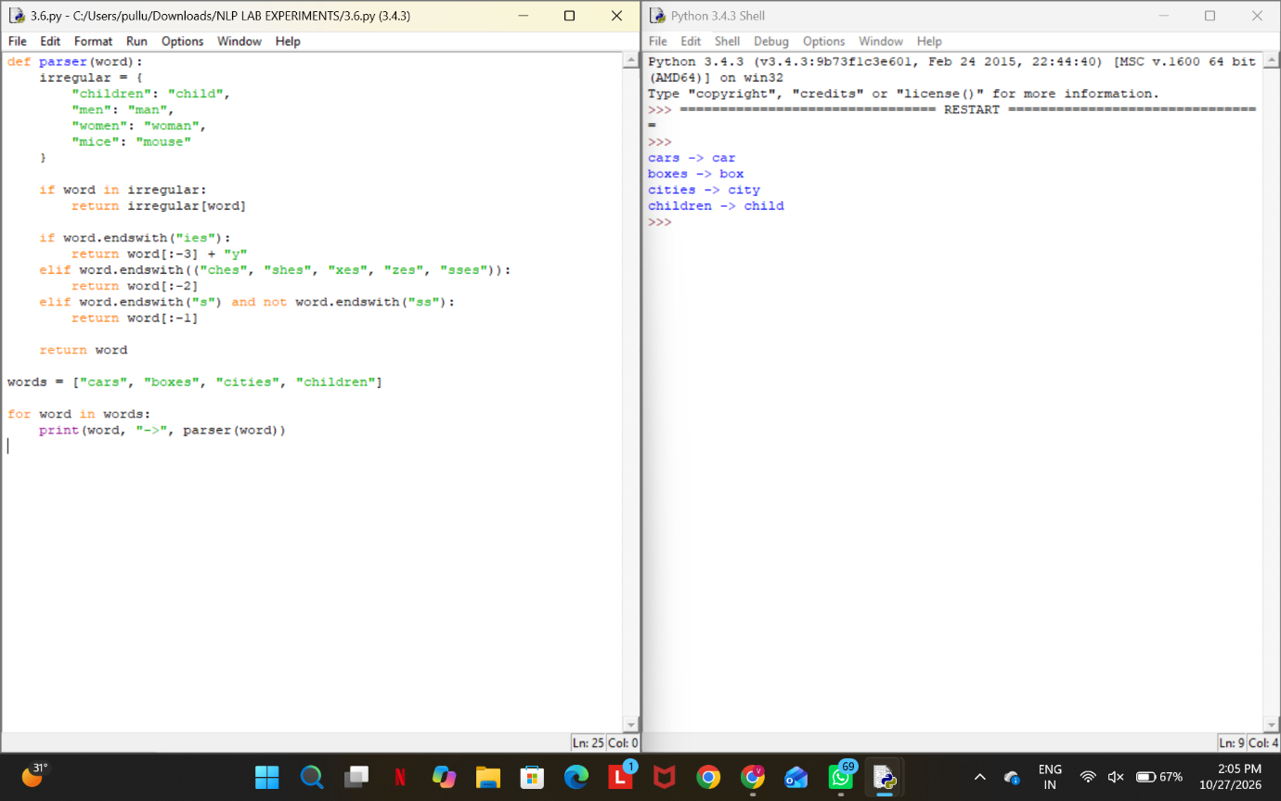
Result
The corrected parser handles the specified regular and irregular plural forms. More rules or a lexical database are needed for complex English words.
7: Morphological Feature Extraction
1. Information about the topic
Feature extraction converts text into numerical data that machine-learning models can process. Stemming before feature extraction helps combine some related word forms into a common feature.
2. Problem statement
The original program extracts the vocabulary first and stems the feature names afterward. This changes the labels but does not combine the corresponding columns in the feature matrix.
3. Aim
To correct the preprocessing pipeline by applying stemming before vocabulary creation.
Code:
import re
from nltk.stem import PorterStemmer
from sklearn.feature_extraction.text import CountVectorizer
stemmer = PorterStemmer()
documents = [
"running runners runs",
"studies studied studying",
"organization organized organizer"
]
def stem_tokens(text):
words = re.findall(r"[a-z]+", text.lower())
return [stemmer.stem(word) for word in words]
# Before stemming
v1 = CountVectorizer()
X1 = v1.fit_transform(documents)
# After stemming
v2 = CountVectorizer(
tokenizer=stem_tokens,
token_pattern=None
)
X2 = v2.fit_transform(documents)
print("Vocabulary before stemming:")
print(v1.get_feature_names_out())
print("Vocabulary size:", X1.shape[1])
print("\nVocabulary after stemming:")
print(v2.get_feature_names_out())
print("Vocabulary size:", X2.shape[1])
Expected output
The program displays the original vocabulary and the stemmed vocabulary, along with both vocabulary sizes. The exact values should be taken from the executed program.

Solution approach
- Read the text documents.
- Tokenize each document.
- Apply Porter Stemmer to every token.
- Create the vocabulary from the stemmed tokens.
- Compare vocabulary size before and after stemming.
Screenshot of the program:
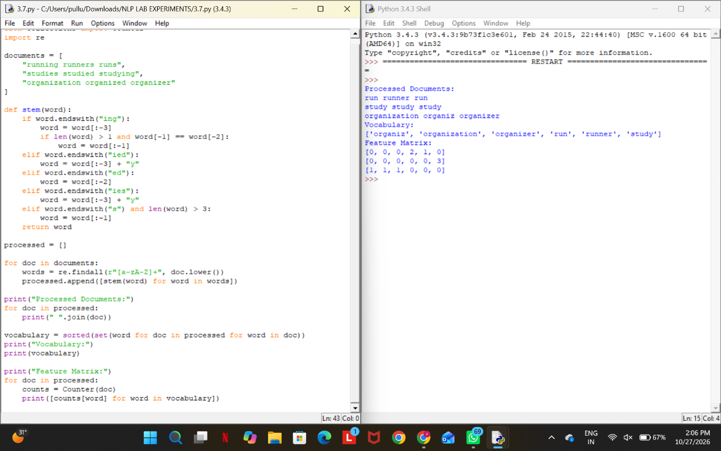

Result
Stemming before feature extraction can reduce redundant vocabulary features. Classification accuracy and processing time must be measured separately to establish whether the change improves model performance.

